STA10003 FOUNDATIONS OF STATISTICS WORK INTEGRATED LEARNING (WIL) ASSIGNMENT PART 2

This **Assignment Part 2** is worth **20%** of your final mark for STA10003.

# Scenario

You have been employed as a new graduate researcher at Social Interactions Australia. Social Interactions Australia conducts research about relationships and other social issues. You have been given a dataset which contains the results of a survey given to Melbourne adults who visited a psychologist in 2022. You have been asked to analyse the data and answer several questions of interest that are presented on the following pages.

# Data Preparation

**For this assignment you will use the random sample of 5000 cases that you used for Assignment Part 1.** If you no longer have this random sample then you have to use SPSS to draw a new random sample of 5000 cases from the data set **STA10003 Sem 2 2024 Assignment Data.sav**.

# Submission Instructions

* Your submission must be a single Word file or PDF file.
* Although a cover page is not required, you should include your name and student number within the document [e.g., in footer].
* You must submit your file via the **SUBMIT ASSIGNMENT** button on the Week 10: Assignment Part 2 page in Canvas by Sunday October 13 by 11:59pm. Only the last document you submit will be marked.
* Once submitted, please review your submission to ensure the correct file has been submitted.
* This is an individual assignment. Do not share your work with other students. They will have a different random sample of data, so any copying will be detected.

# Plagiarism and Maintaining Academic Integrity

This is an individual assignment, so you are expected to complete it by yourself. It is important that you demonstrate good Academic Integrity by ensuring that your assignment work is entirely your own, because this shows that you have understood what you have learnt. You should not use the work of anyone else, including that of another students, for this assignment. Whilst you may seek help if there is anything about this assignment you do not understand, the assignment must be your own work.

Use of generative AI such as ChatGPT is not permitted. Any form of copying or submitting work that is not entirely done by you is a breach of academic integrity and could attract academic penalties. Your work will be checked for breaches of academic integrity.

**For your Assignment Part 2, you are required to complete the first three (3) questions by producing the appropriate analyses using SPSS and writing the relevant report for each question. You are also required to complete question 4, which contains short answer questions.**

For each of the first three questions you must include all relevant output immediately following each report. Provide all statistics to two decimal places, expect the p value which is given to three decimal places.

# Question 1

Researchers predicted that the level of conflict in relationships for Australian adults is lower than it was in 2020. Previous research indicated that for Australian adults the average level of conflict in relationships in 2020 was 90. The level of conflict in relationships is measured on a scale from 0 to 200, with higher values indicating a higher level of conflict in relationships. Conduct a one-sample t-test to test this prediction. Produce the relevant SPSS output, and write a one-sample t-test report based on your output. Include the relevant output after your report.

A one-sample t-test is conducted to compare the level of conflict in relationships of Australian aldults in 2022 and 2020. It is clear from the table that the sample consisted of 4162 out of 5000 in total. Notably, the intensity of conflict in relationships in 2022 (M = 81.85, SD = 43.174) was significantly lower than the 2020 mean of 90. Furthermore, the test value was set at 90, and the results demonstrated a statistically significant difference, t(4161) = -12.175, p < .001, α = 0.05. Moreover, 95% confidence interval for the difference ranged from -9.46 to -6.84 and the Cohen’s d (Point Estimate) was – .189, indicating small effect. In conclusion, the results of one-sample t-test support the prediction that level of conflict in relationships in the year 2022 of Australian adults was lower than in 2020.

# Question 2a

Researchers predicted that the level of happiness in relationships reported by Australian adults is lower for males than for females. The level of happiness in relationships is measured on a scale from 0 to 100, with higher values indicating a higher level of happiness in relationships. Conduct an independent samples t- test to test this prediction. Produce the relevant SPSS output, and write an independent samples t-test report based on your output. Include the relevant output after your report.

An independent sample t-test report is conducted to compare the level of happiness in relationships differed between Australian adult males and females. As a results, the mean happiness score of male adults (M = 52.89, SD = 17.614) was slightly higher than that for females (M = 52.81, SD = 17.476). Howeverm the difference between these two groups is not signifcant, t(3739) = -.136, p = .982 ( 2-tailed). It is clear from the result that the mean difference was -.078 with the 95% Confidence Interval ranging from -1.203 to 1.047. As a result, these findings cannot support the prediction that the level of happiness in relationships reported by Australian adults is lower for males than for females.

# Question 2b

Check and comment on the assumptions of the independent samples t-test you did in Q2a. Include the relevant output with your answer.

To validate the independent samples t-test comparing happiness in relationships between males and females of Australian adults, assumptions were assessed. Levene's test (F = .133, p = .715) indicated equal variances, satisfying that assumption. Therefore, independence is assumed based on study design. However, normality was not directly tested in the output. While the large sample sizes offer some robustness, ideally, normality checks would be included for a complete evaluation

# Question 3a

Researchers predicted that for Australian adults the level of commitment to relationships is higher than the level of intimacy in relationships. The level of commitment to relationships and the level of intimacy in relationships were both measured on a scale from 0 to 120, with higher values indicating higher levels. Conduct a paired samples t- test to test this prediction. Produce the relevant SPSS output, and write a paired samples t-test report based on your output. Include the relevant output after your report.

A paired samples t-test report is conducted to compare that the Australian adults the level of commitment to relationships is higher or not than the level of initmacy in relationships. According to the results, the mean difference between the level of commiment and inimacy in relationships of Australian adults was -27.045, (SD = 30.138), indicating that the level of intimacy was significantly higher than the level of commitment. As a result, this difference was statistcally significant, t(3354) = -51.977, *p* < .001 (two-tailed), *d* = -0.897, 95% CI [-28.07, -26.03].

# Question 3b

Check and comment on the assumptions of the paired samples t-test you did in Q3a. Include the relevant output with your answer.

To assess the reliability of the paired samples t-test results, assumptions is nessecary. In addition, the test assumes independence of pairs, meaning the difference scores are unrelated across individuals, which generally assume is met through proper study design. Therefore, the second key assumption is the normality of difference scores. While the provided output lacks direct tests for normality, such as the Shapiro-Wilk test or visual inspections, the large sample size (df = 3354) suggests the test is robust to moderate violations of this assumption. However, a more comprehensive analysis would include normality checks to confirm this assumption.

# Question 4: Does not require SPSS

Previous research has suggested that among adults who live in metropolitan Melbourne 37% used public transport in the last month. A researcher working for the Melbourne City Council wants to know if the percentage of adults who live in metropolitan Melbourne who used public transport in the last month is different to 37%. The researcher takes a random sample of adults who live in metropolitan Melbourne to find out what percentage used public transport in the last month.

1. What type of statistical test would be appropriate for the researcher to use?

* From my perspective, type of statistical test would be appropriate for the researcher to use is the one-sample z-test for the researcher to use.

1. Explain why this statistical test would be appropriate.

* In my opinion, the one-sample z-test would be appropriate because the researcher compares the proportion of adults in the sample who used public transport in the last month to a known population proportion (37% or 0.37). Moreover, the data is categorical, and researcher is interested in the proportion of individuals within the sample who fall into a specific category. Additionally, a z-test is suitable for a large sample size. Due to these reasons, one-sample z-test is appropriate in this research.

1. If a Type I Error occurred what conclusion would the researcher make?

If a Type I Error occurred, the researcher would conclude that the proportion is different from 37% when it is not.

1. The researcher conducted the appropriate statistical test and obtained a p-value of 0.053. Based on this result the researcher concluded that there is no evidence to suggest that the percentage (proportion) of adults who live in metropolitan Melbourne who used public transport in the last month is not different to 37% (different to 0.37). Is this conclusion valid or not valid? Explain why this conclusion is valid or not vsalid.

* The conclusion is valid because P-value (0.053) is greater than the typical significance level (0.05), as a result, reseacher fail to reject the null hypothesis.

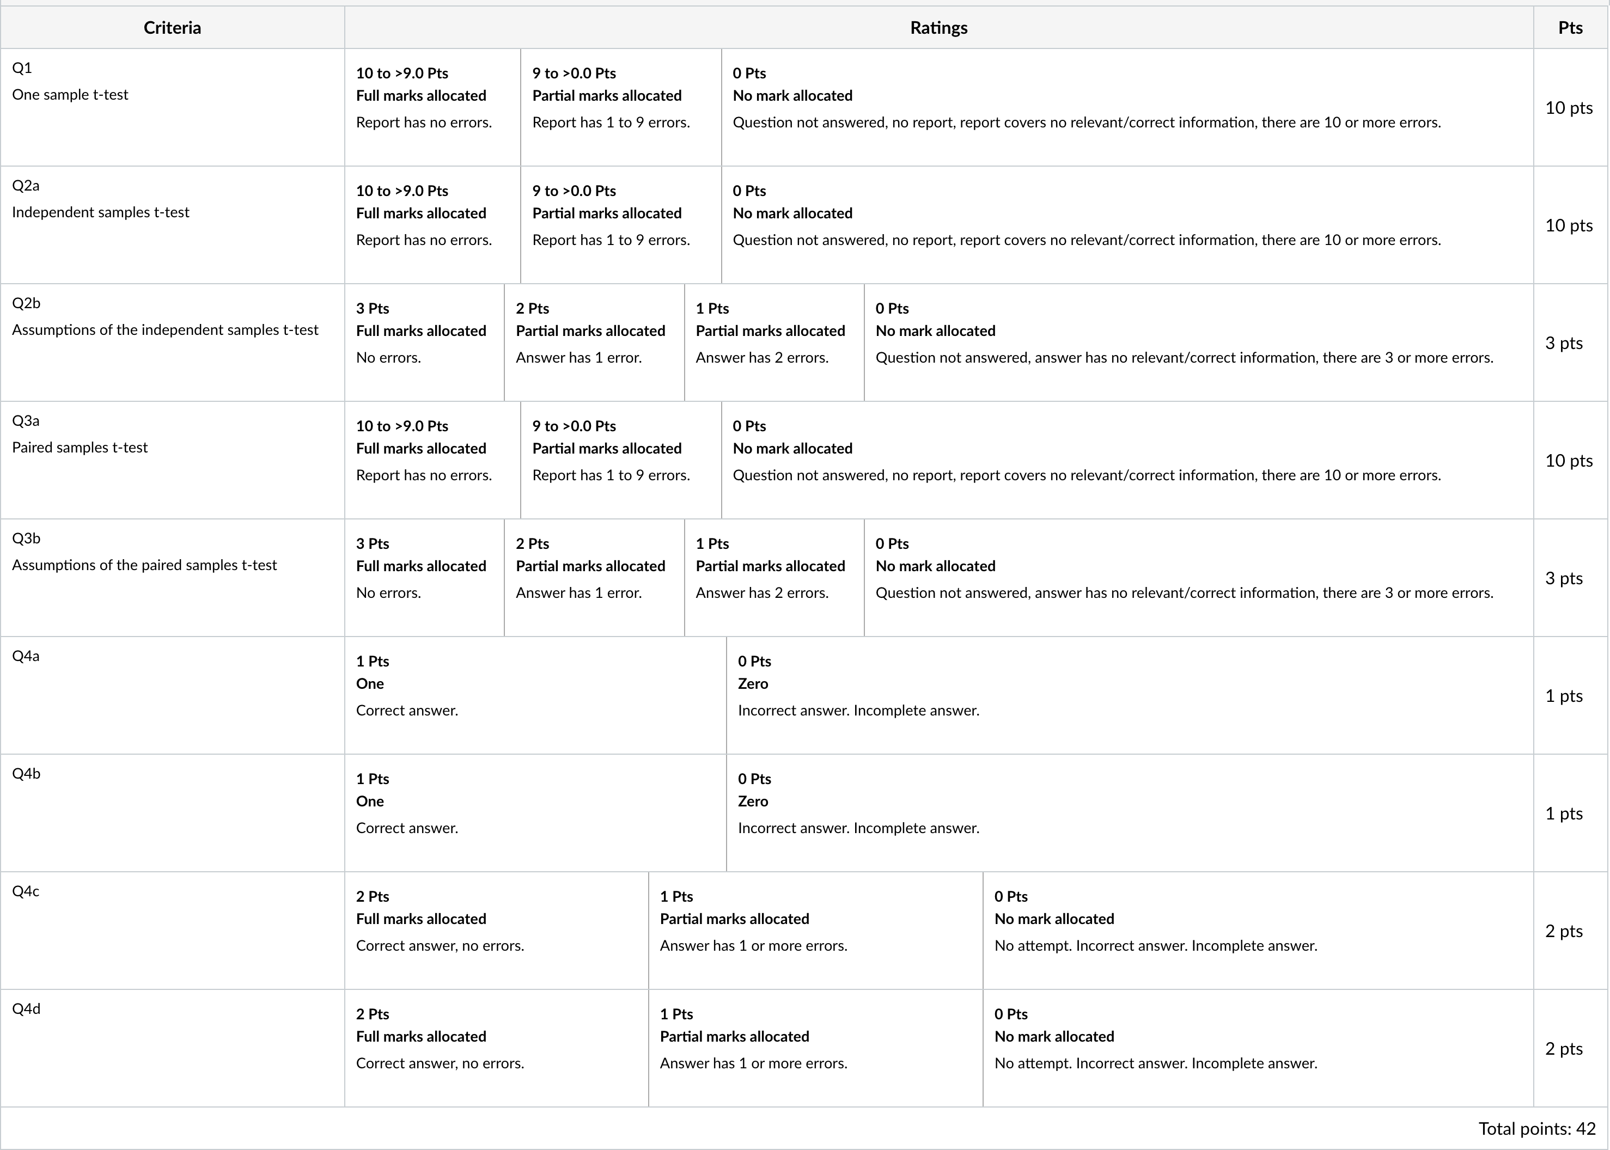STA10003 Assignment Part 2 Marking Rubric

Prior to submitting your Assignment via Canvas, use the following checklist as a guide to ensure that all of the relevant information is provided in your reports.

# Checklist:

* Correct variable(s) used to produce output
* Correct procedure performed
* Correct test values used
* Including 95% confidence interval interpretations
* Significance interpreted correctly (i.e. not saying that the finding is significant when it is not or vice versa)
* Correctly referring to the sample or population when appropriate
* Proof reading of reports for errors